How to locate and access IEP Goal Development
- Go to www.esc20.net
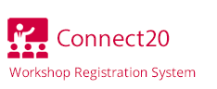
- Click on

- Type the Session # into the search tab:

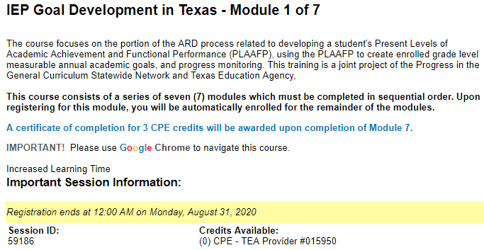

- Sign in or Create an Account if you do not have one

- Enroll in the course. (Deadline for completion is September 9th)

**This is a course that does not require 3 hours of consecutive time. If you need to logout during the training, it will pick up where you leave off.

At completion, you will receive a certificate for 3 hours of training.
Please turn this in to your Department Chair.

