Best Practices
for electronic communication about students

We understand that email is an integral form of communication in our jobs.

- Guidelines

  - Only email identifying (name, DOB, grade) information about a student to other staff that need to know (ex: other special services staff, case managers, department chairs, administrators, etc.)
  - Whenever possible, use initials rather than the whole name
  - Whenever possible, password protect attached documents with identifying information (see attached instructions)
  - Before sending the email with the student’s identifying information, pretend that you are going to CC the email to a judge. If you feel comfortable with a judge reading your email in court, then send it.
  - Never use personal email accounts to send/receive information about students. Only use your district email account.

How to password protect a Word Document:
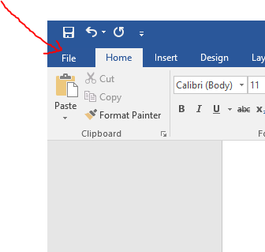
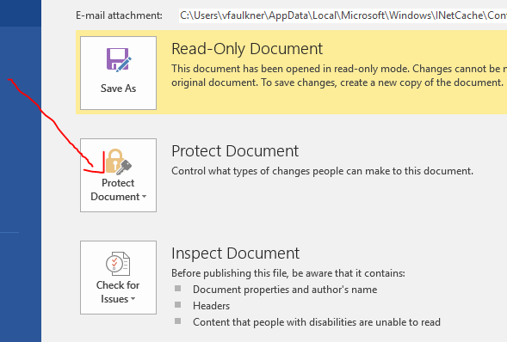
Click “Encrypt with Password”
Enter a password (ex: student’s birthdate).
Do not send the password to the recipient in the same email as the attachment – send the password in a separate email.

How to password protect a PDF:
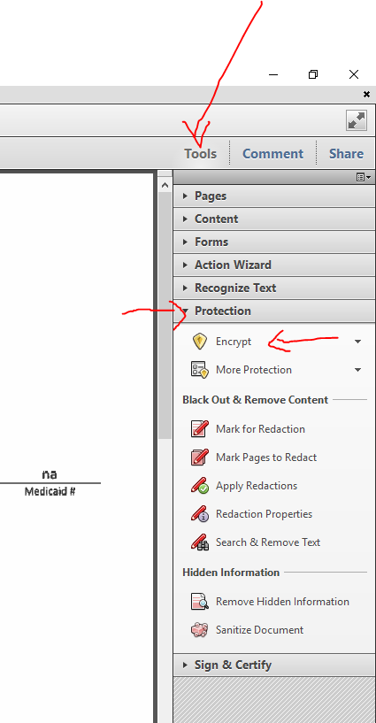
Click “Encrypt with Password”
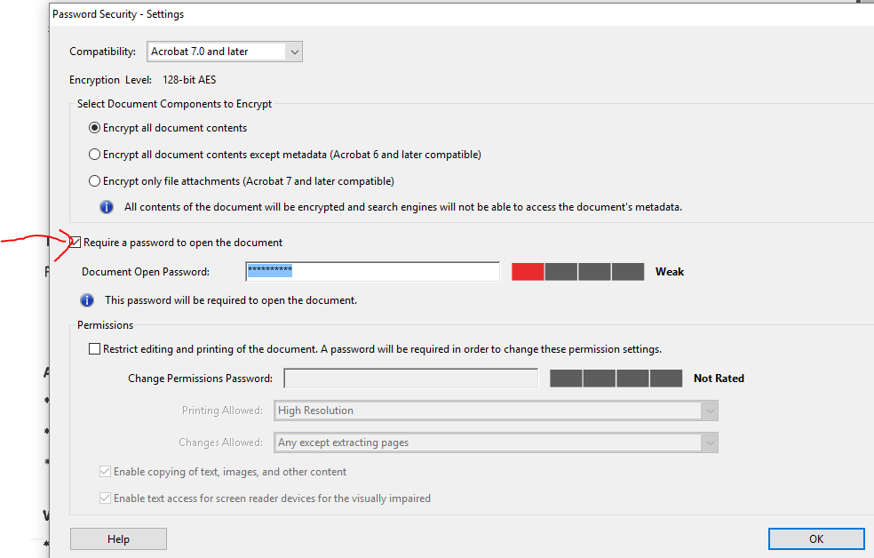
Enter a password (ex: student’s birthdate). Click ‘OK’ and then save the document. Do not send the password to the recipient in the same email as the attachment – send the password in a separate email.

