DRAFT ARD PROCEDURE

- Purpose: provide a temporary working copy (draft) of the ARD document.
- Uses: INITIAL, ANNUAL and 30-DAY PLACEMENT ARDs.
- A Draft is NOT for Review ARDs, Revision ARDs, Dismissal ARDs, IEP Amendments, Notices, or FIEs.
- Timeline creation is 2-3 weeks prior to ARD meeting.
- If need for MDR, Draft must be deleted.
- Difference: Active (official record); Draft (temporary working copy).
- Draft Location: Other section of the ARD application.
- When a Draft exists, all new data must be entered into the Draft, except for Progress Reports which go into the Active record.

- Creating a DRAFT Record

- From ARD forms select the student as usual. Scroll down to Other and click Process Draft Record.

When a Draft is created, all information from the student’s current Active record is duplicated EXCEPT checked items in the Process Draft Record screen. Screens in other applications, such as Notices, eFIE and REED, are “cloned” 100%.

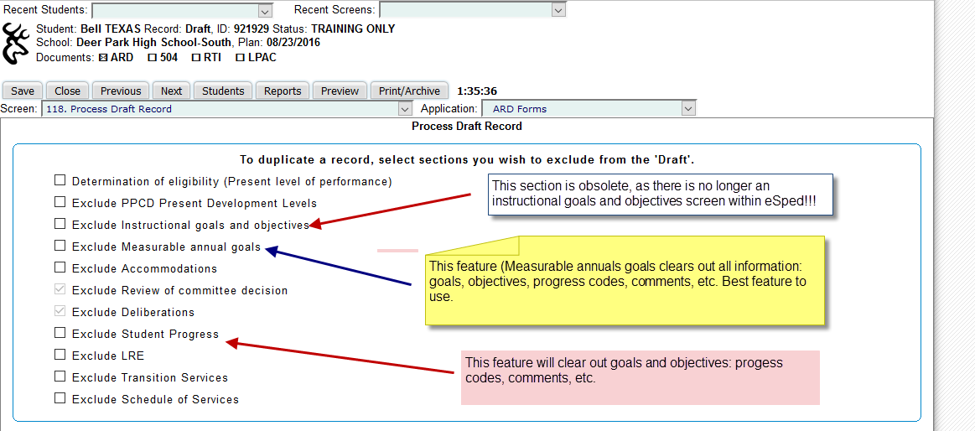

- Click Create Draft
- Click OK. The Select Student screen appears. Note: students appear with the same name – one is Active, the other is Draft.

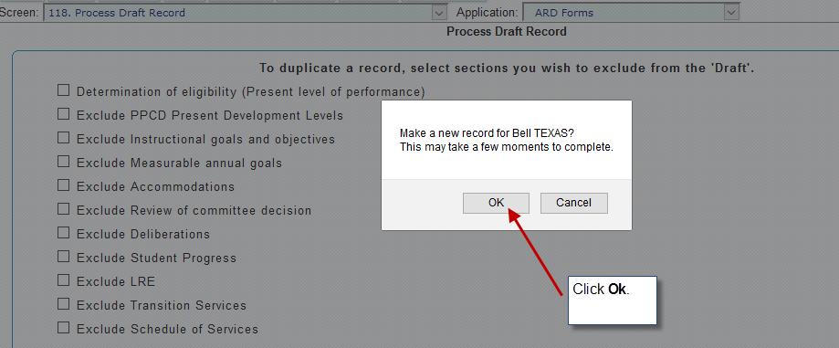

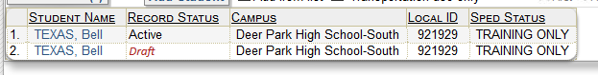

There are now two records: Active (current official record) and Draft (temporary working copy to begin preparation for upcoming initial/annual/30-day permanent placement ARD meeting. NOTE: Next to the student’s name – top of the screen will say either Draft of Active as a reminder of which record is open.

Before the annual ARD, Progress Reports for IEP goals/objectives should be updated in the Active record and archived. THIS IS A MUST!! IT MUST BE COMPLETED BEFORE CONVERTING THE DRAFT RECORD TO ACTIVE.

- Converting the Draft record to Active Record

Once the ARD meeting is concluded, all documentation is complete and PEIMS date checked and validated, the DRAFT record is to be converted to the new ACTIVE by following the steps listed below. Following the conversion, the FORMER ACTIVE record is moved “behind the scenes” to the Deleted Student bin and labeled LAST.

IT IS IMPERATIE THAT IEP PROGRESS REPORTS ARE UPDATED AND ARCHIVED PRIOR TO THE FOLLOWING STEPTS!!!

- While in the Draft record, go to the screen titled Process Draft Record. This screen is located towards the end of the screen list.

- Click Make Draft Active for <Name of Student>

- One of two pop-up messages will appear:

3a. “The record will become Active and all others will be deleted, continue? Click OK. Now, only the Active record is visible. NOTE: “All other” records are not actually deleted, they just go behind the scenes to the deleted student bin and re-named the LAST record.

3b. If the Draft record contains fatal PEIMS errors, it cannot be made Active. Click OK, fix PEIMS data areas and return to activate the record.

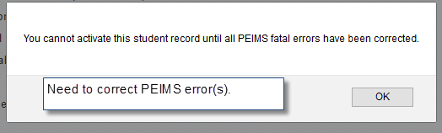

REMEMBER*

- Draft record should not be created too far in advance. This could create an issue if an immediate ARD is needed (i.e., MDR).

- Follow rules for which record to enter data to eliminate data “loss” and so that all data is available when the record is converted to Active.

- Do not leave a record in Draft too long after the ARD meeting. Typically, administrative reports are pulled from the Active record (PEIMS, STAAR testing lists, FIE, or ARD date lists, etc.), since it is the “official: record. Records left in Draft form after the ARD meeting could contain official data that are unavailable for administrative reports.

- The FINAL UPDATE of progress is the only exception since it is completed in the ACTIVE record even when a draft exists. Typically, goals and objectives are not copied into the Draft record and would not be available within the Draft record for updating progress.

*eSTAR, 06/20/16

