Entering IEP’s in eStar
- Log into eStar using your username and password.
- Click Ard Forms and select your student
- Select FERPA Reason: (I am writing the student’s IEP)
- Screen: Use dropdown and select: Measurable Annual Goals (it should be around screen 15)
- Click “Add new goal”
- Enter Goal Number (#1) and Duration (Ex: 8/21/2019 – 5/24/2020)
- Do not add any “General Modifications and Accommodations” at this time.
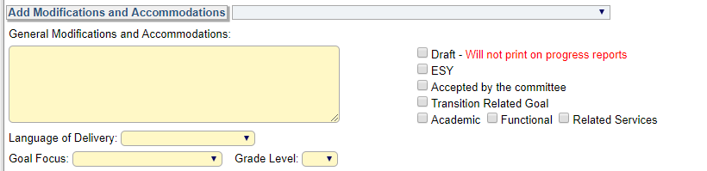
- Click “draft” and “academic, functional, or related services”
- Enter “Language of Delivery” (English is located at the bottom)
- Enter “Goal Focus” from dropdown
- Add Student’s Grade Level
- Skip down to the “Measurable Annual Goal” text box and enter the annual goal for your student.
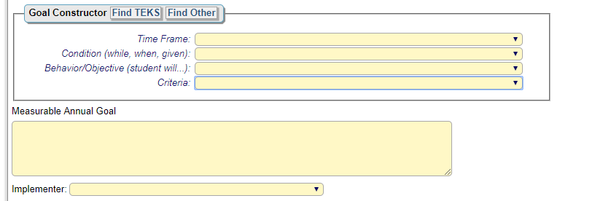
Example: (Standards-based IEP)
By the end of the 2019-2020 school year, given a calculator and labeled 3-dimensional geometric figures, ____ will correctly calculate the volume of a figure in 7 of 10 problems.

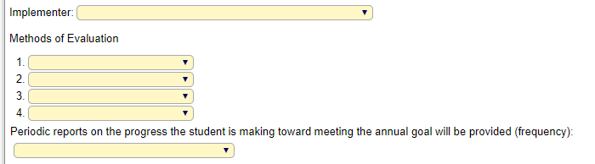
- Enter “Implementer”
- General Ed/Special Ed Teacher – (ex: if student is in a co-teach classroom)
- Special Ed Personnel – (ex: if student is in a resource, life Skills, SLC, SLS, etc. classroom)
- Enter “Methods of Evaluation” (select from the dropdown)
- Enter frequency of periodic reports from dropdown
- Select: “end of each grading period”
- Go back up to top of page and “save”
- After you save, your first goal will appear
If you are developing only goals for your student, you follow the same procedure and enter all of your goals for that student. Make sure you number all of your goals when you add them.
If you are working with students on a modified/alternate curriculum, you must have goals & objectives. You must have a minimum of 2 objectives for each goal.
- At the bottom of the screen, click on “Create New Objective”

This screen will appear when you click “Create New Objective”
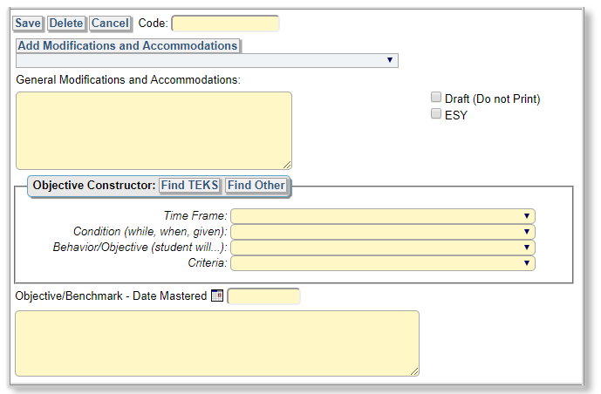
- Click on “Draft” on the right side of the screen
- Do not enter anything in the “General Modifications and Accommodations“ section.
- In the Objective/Benchmark box, enter your short-term objective that is linked to your annual goal.
- Ex: By the end of the first grading period, when given a calculator and labeled 3-dimentional geometric figures, ____ will calculate the volume of the figure in 3 of 10 problems.
By the end of the third grading period, when given a calculator and labeled 3-dimentional geometric figures, ____ will calculate the volume of the figure in 5 of 10 problems.

Click “save” at the top of the screen. You should see your annual goal and the two objectives in this example.
Click “Add New Goal” and start the process again until you have entered all of your goals and objectives for the student.
REMEMBER: You must write goals/objectives for the current year and for the beginning of the next school year to cover until the next annual ARD meeting.

