Entering Accommodations into the Comment Field in the Gradebook

Comments can be entered for the Student Assignments in the Score Entry area.
The Comment field is a “free-form” entry.
Several recommended comments are shown in the picture below.
**The Comment field “remembers” the comment text that you have previously entered.

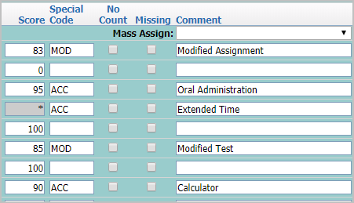
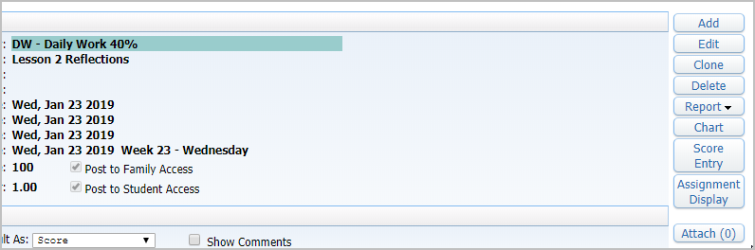

Besides the “COMMENT” field, you can enter the Special Code of MOD or ACC for the assignment.
You can enter MOD as a visual reminder that the grade is a Modified Assignment or a Modified Test.
All other types of Modified Curriculum are an Accommodation. Use the ACC special code for those.
The Special Code can be entered…..along with an assignment grade.
The Special Code can be entered…..instead of an assignment grade.
