eSTAR UPDATES

- Changes to Consolidation of Important Dates screen: ARD forms and eFIE
- ARD forms

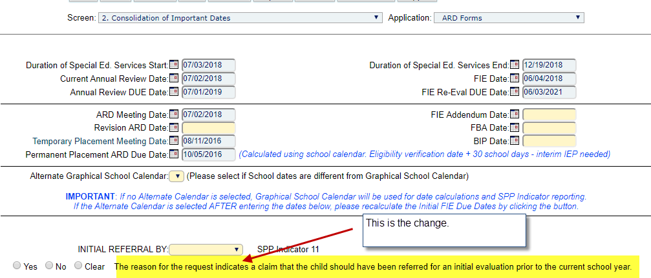

- eFIE

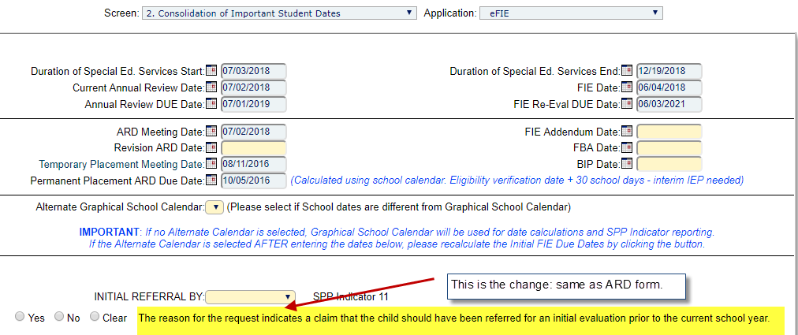

- The information completed in ARD forms will appear in the eFIE and vice versa.

- Two screen changes in Notices: Evaluation Consent and Educational Screen/Initial Referral – 1.
- Evaluation Consent

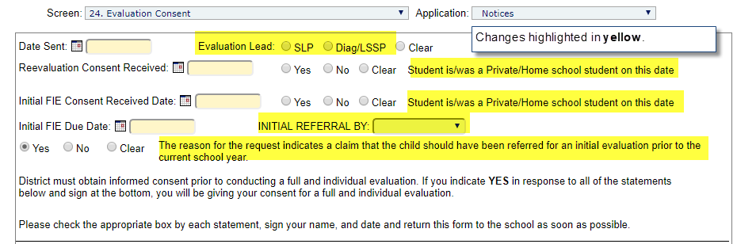

- Educational Screen/Initial Referral – 1

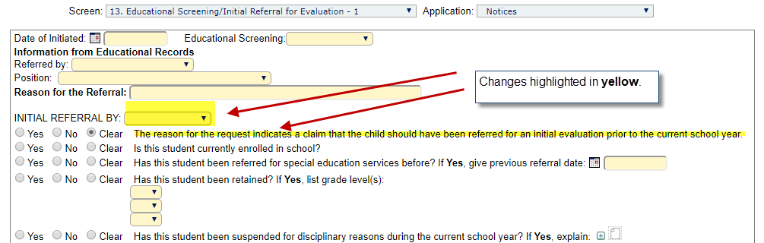

- Changes to Schedule of Services screen, ARD Forms – has not become available, yet.
- Current

- What is to come
