**Event Invitations Using Outlook – Cheat Sheet**

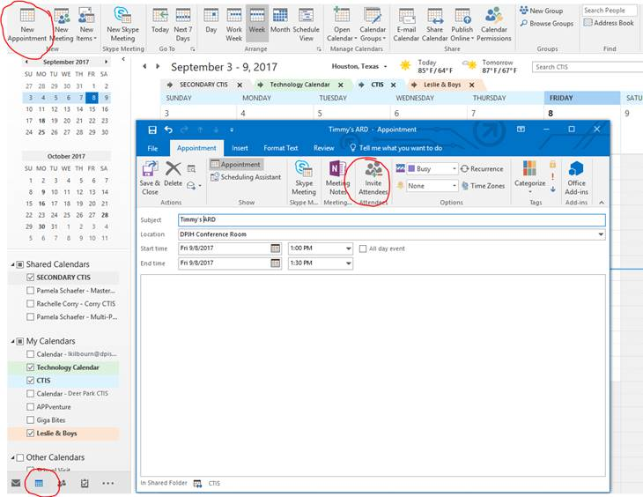

1. **Open Calendar**
2. **Select New Appointment – add subject, location, start time & end time**
3. **Select Invite Attendees – add all the necessary people**