FRONTLINE SPECIAL EDUCATON & INTERVENTIONS V3

- Changes: New NAVIGATION system (Navigation Mapping) – information for each application is contain within respective files

- 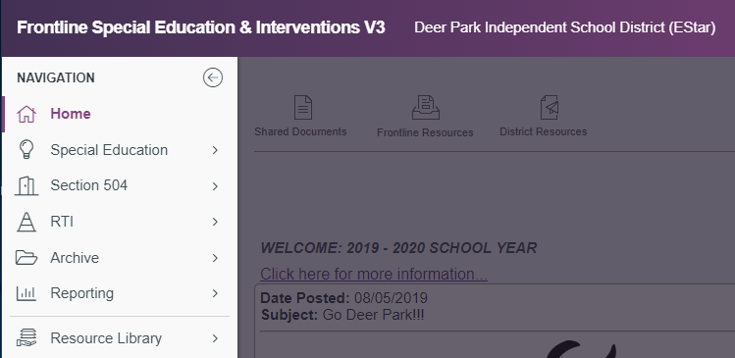

Special Education

- 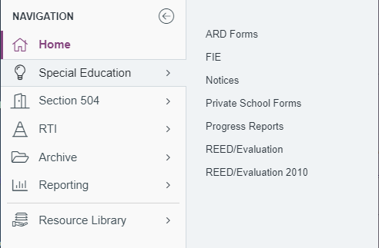

504 Plan

- 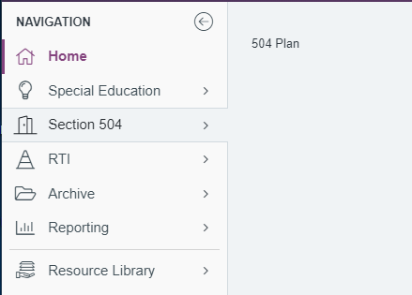

RTI

- 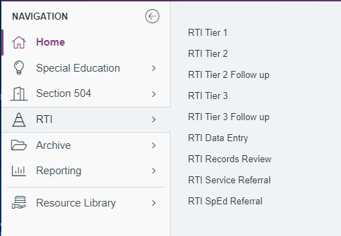

Archive

- 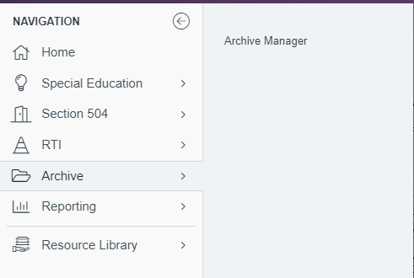

Reporting

- 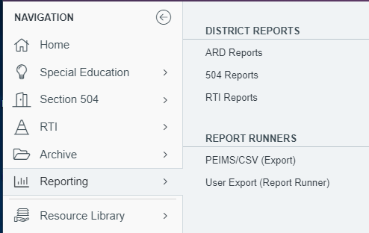

Resource Library

- 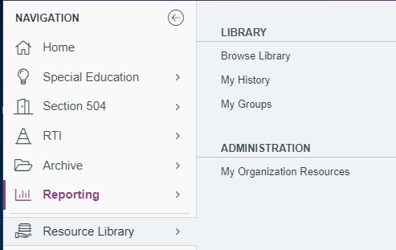

- Reminders:

- DRAFT
- DO NOT create a DRAFT for an Initial ARD. DRAFT is for Annual ARD only.
- Change “DRAFT” to “ACTIVE” at the conclusion of the ARD meeting – DO NOT wait until ARD is processed.
- Determine who will make “DRAFT” Active.
- DO NOT create a DRAFT for a Revision ARD.

- FIE
- Reasons for Discontinuance of Initial Evaluation located in Screen 2. Consolidation of Important Student Dates in the FIE Application. This is, also, located in Screen 3. Consolidations of Important Dates in the ARD Forms application. It is populates between the two applications!

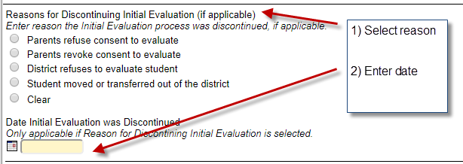

- FIE (Initial) not done in Frontline, go Screen 2. Consolidation of Important Student Dates in FIE. Enter Initial FIE Date. Date will populate to ARD forms.

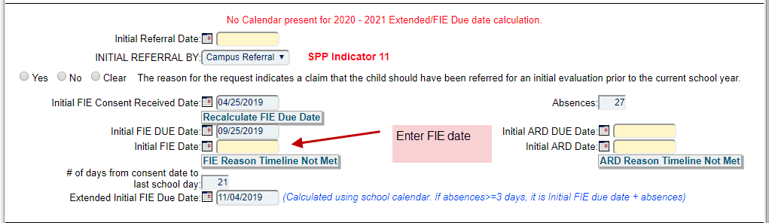

- ARCHIVE ARDs and IEP Amendments as soon as possible. Too much trouble to remember and recreate dates after another ARD or IEP has taken place.

