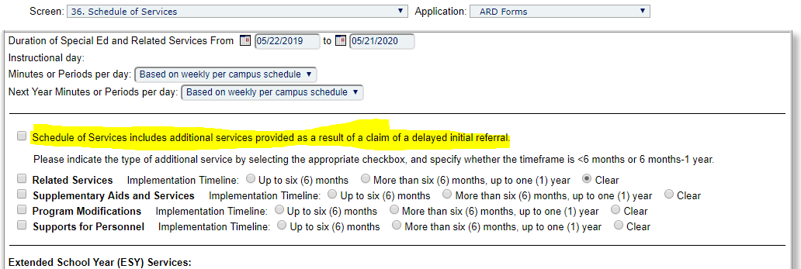

**Never check this unless there has been a staffing to review this with Pam.**