STATE PERFORMANCE PLAN INDICATORS

Indicator 7 – EARLY CHILDHOOD OUTCOMES

- Child Outcome Summary Form (1)

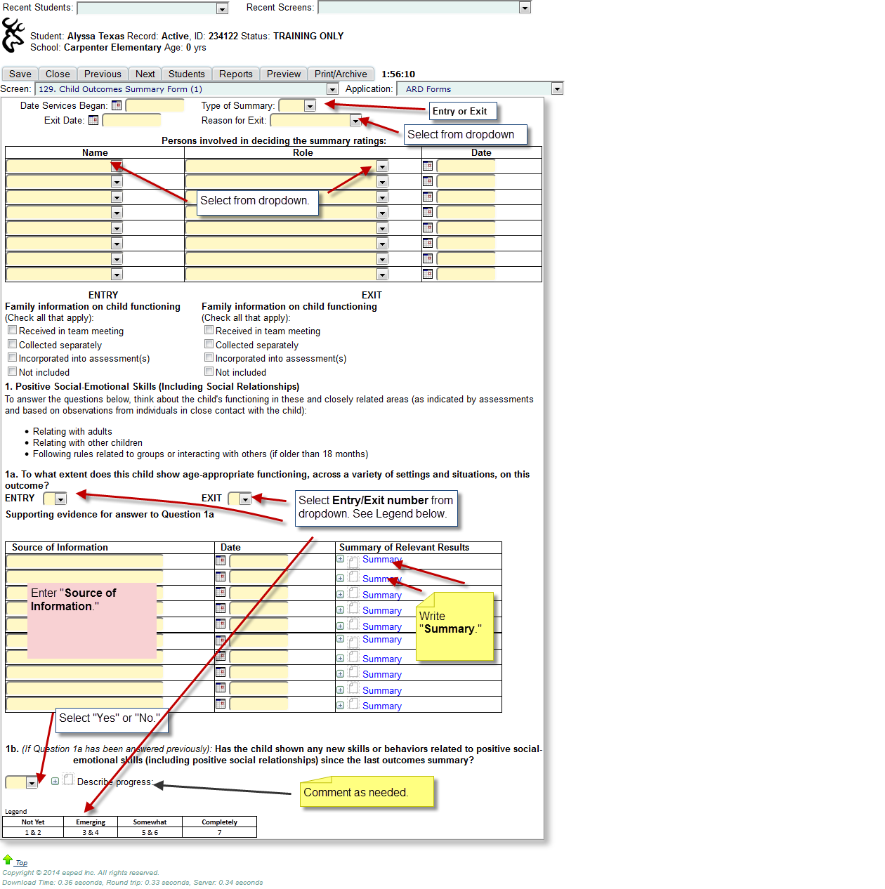

- Child Outcome Summary Form (2)

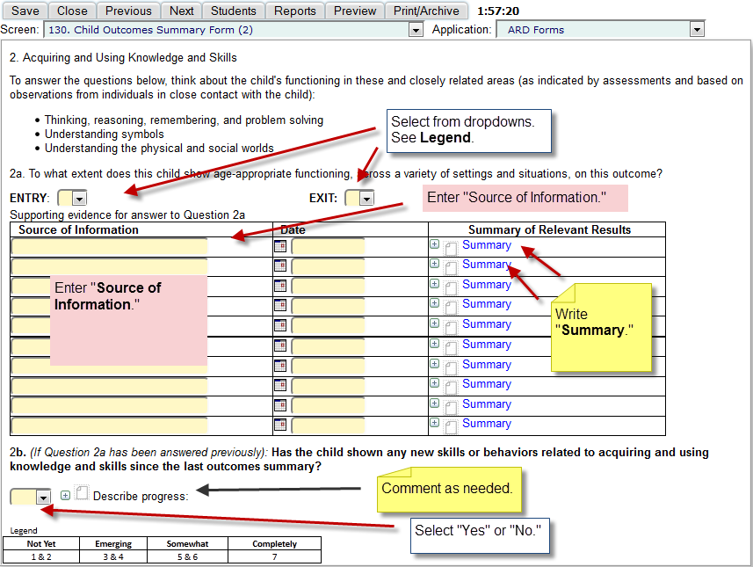

- Child Outcome Summary Form (3)

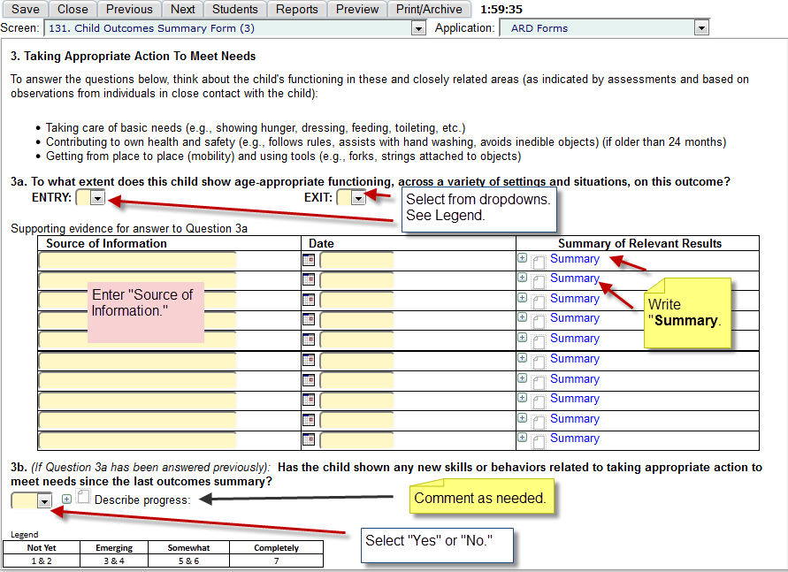

Indicator 11 – CHILD FIND – data is pulled from two sources: Consolidation of Important Dates screen and Review of Additional Evaluation/Information screen in the ARD application. Focus is on Initial FIE Timeline and Initial ARD Timeline.

- Consolidation of Important Dates

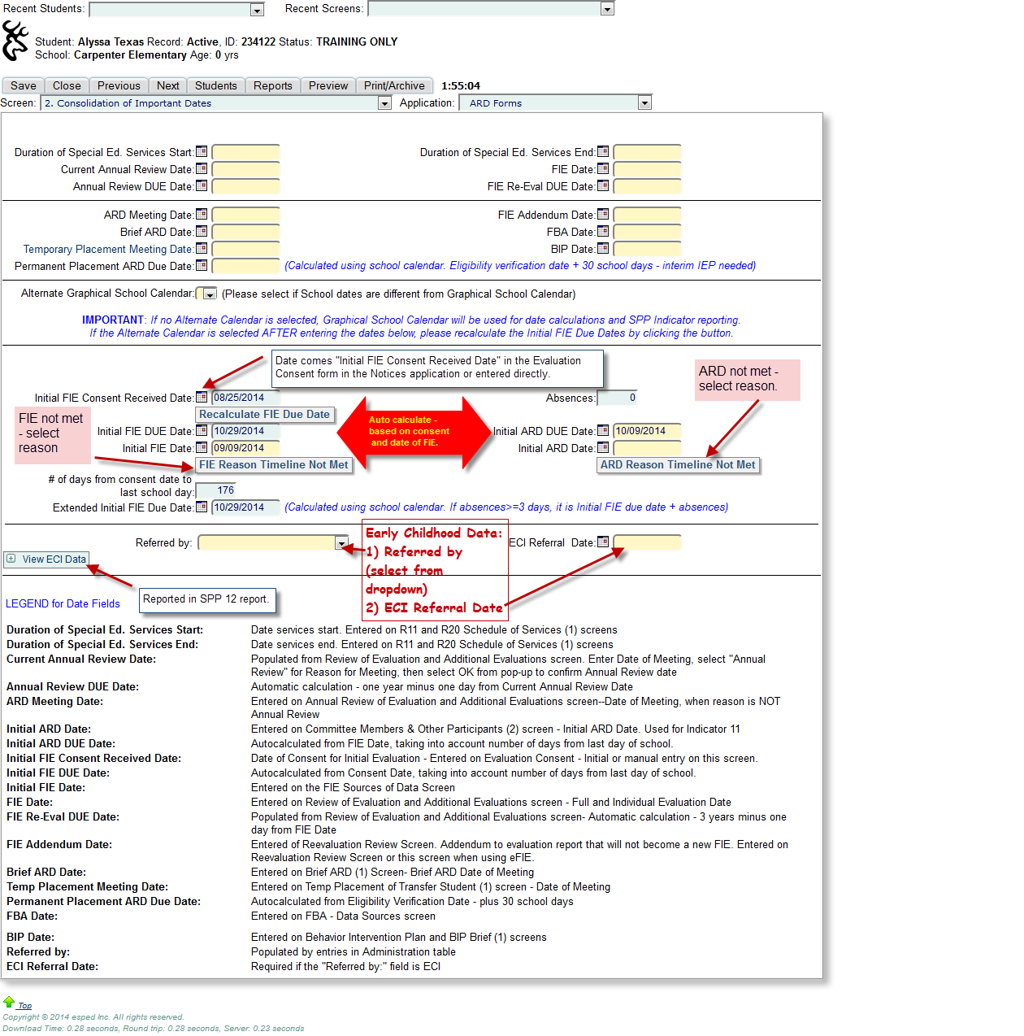

- ECI Information to remember:

- Initial ARD Date and 3rd birthday. ARD date may be entered directly on the consolidation date screen or into the associated field on the Committee Members and other Participants (2) screen. Student’s 3rd birthday auto calculates.

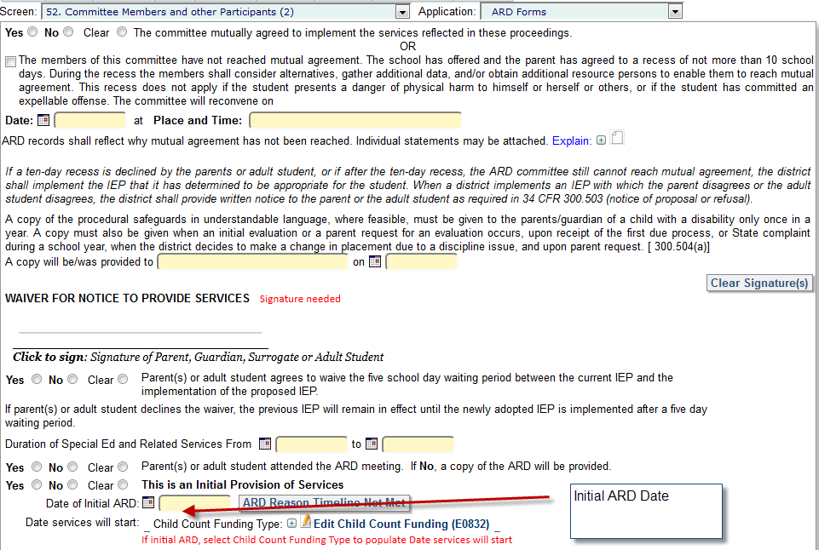

- Compare ARD Date and student’s 3rd birthday. If ECI Timeline is not met (3 is 3), since ARD was held after 3rd birthday, a reason must be entered in one of two places.
- If one of the reasons in the area on the left, choose one of the radio buttons (and checkbox in the top area). This student will be IN compliance with SPP 12.
- If reasons on the left do not apply, then select one from the ECI Reason Time Line Not Met dropdown. This student will be OUT of compliance with SPP 12.

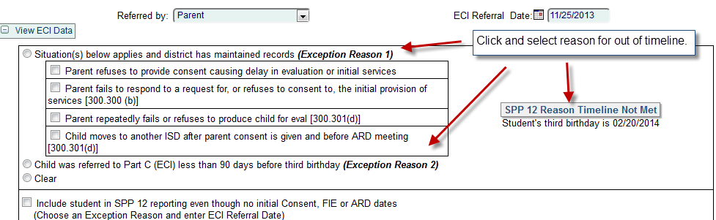

- Reason Timeline Not Met – If Initial FIE or Initial ARD is past due, a message box will appear requiring the selection of a reason. Click on the dropdown to select a reason. This reason will appear on the SPP 11 administrative report. If either of the last 2 reasons apply (Parental delay or Student transfers – need good records in both cases), click the Compliant box at the top. The student will show as compliant on the SSP 11 administrative report.

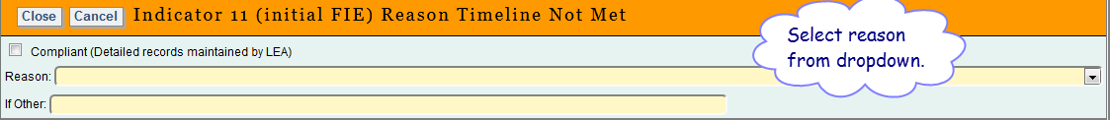

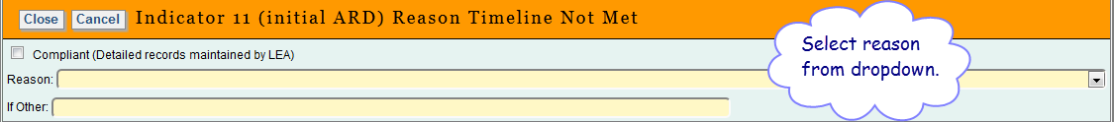

- Does NOT Meet or Meets criteria for – must check radio on the Review of Additional Evaluation/Information screen. If not completed, the information will not appear in the SPP 11 administrative report. This is important for SPP 12 report, as well.

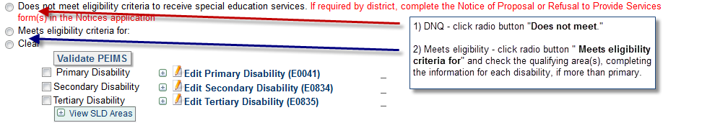

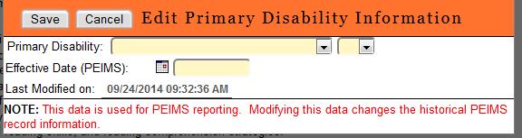

Indicator 12 – EARLY CHILDHOOD TRANSITION – information is pulled from the Consolidation of Important Student Dates screen and the Review of Additional Evaluation/Information screen in the ARD application.

- Consolidation of Important Student Dates screen

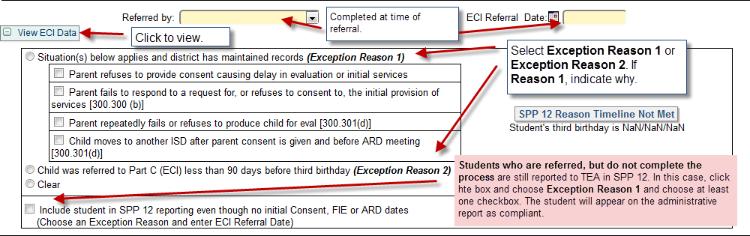

- Reason Timeline Not Met

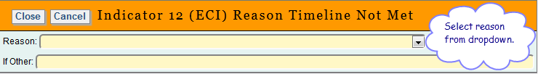
- Does NOT Meet or Meets criteria for – must check radio on the Review of Additional Evaluation/Information screen. If not completed, the information will not appear in the SPP 11 administrative report. This is important for SPP 12 report, as well.

