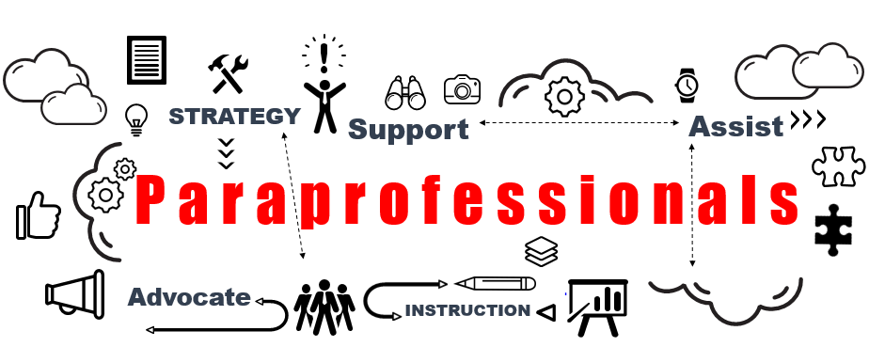

**What is a paraprofessional?**

A paraprofessional is a school employee who assists and supports teacher-directed instruction. Paraprofessionals work under the direction of certified/licensed personnel who maintain responsibility for the design, implementation and assessment of learner progress, and the evaluation of the effectiveness of learning programs.

Under the supervision and management of teachers or administrators, paraprofessionals may prepare learning materials, assist in instructing individuals and small groups of students, and work on a one-to-one basis with students who have special needs. It is imperative for paras to have well developed personal skills that enable them to participate meaningfully in teamwork and effectively support all students, regardless of their individual needs and challenges.

**ALSO Responsible For:**

* Following the school philosophies, guidelines and procedures.
* Knowing and practicing good professional ethics.
* Using good judgement when unusual situations arise.
* Recognizing the role of the principal as the building leader.
* Recognizing that the supervising teacher has the ultimate responsibility for instructional planning and classroom management.
* Following the directions and plans provided by the principal and/or supervising teacher.
* Asking clarifying questions whenever necessary.
* Understanding the distinction between the role of para and teacher.
* Working under supervision within a framework of standard policies and procedures.

**Roles & Responsibilities**

* Implementing team-based assignments
* Building and maintaining effective communication and relationships
* Organizing learning experiences for students.
* Implementing lessons initiated by teacher/relate-services personnel.
* Assessing student needs and progress under teacher direction.
* Maintaining a safe learning environment.
* Exercising good judgment, flexibility, creativity and sensitivity in response to changing situations and needs.
* Assisting in the instructional process and communicating about students’ progress and needs with the teacher.
* Participating in training to develop the knowledge and skills to become a more effective para.