Steps for Completing an IEP Amendment in eSped
To Complete an IEP amendment, go to ARD Forms, select student, click on appropriate FERPA comment, go to dropdown and select the screen “IEP Amendment” (around screen #88)

“This is an amendment to the IEP developed on ____” – You put the date of the last ARD that you are making changes to.

“Proposed implementation date: ____”- You put the date you want the amendment changes to begin.

“Parent/Adult Student were contacted by” – You need to put your name and title along with checking how you contacted the parent and date on which you contacted the parent.

Check appropriate boxes on the section below.
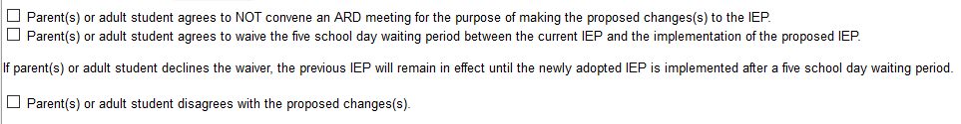
Check all boxes that apply to what you are changing in the IEP Amendment: See below.
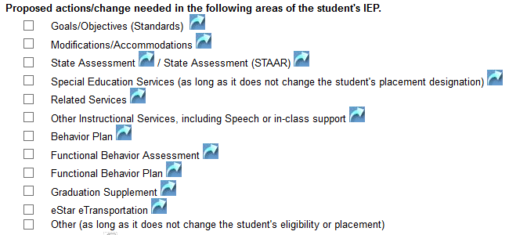

Click inside each box and type in your information:
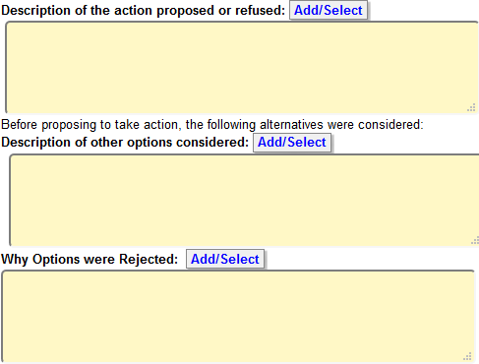
Other factors relevant to the proposal or refusal: Explain:
Click on the paper icon if there is relevant information you need to add.
Deliberations: Click on the paper icon and type in the deliberations box what you are proposing in this IEP Amendment.

At the bottom of the screen, you will see this:

Click on “NEW” and this will pop up.
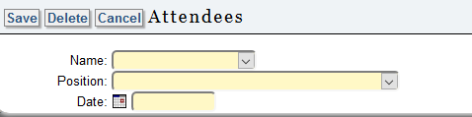

This is where you will add: (You have to click ADD after you save each person.)
- Parent/Adult Student Name and Date – click save
- Teacher Name/Position and Date – click save
- District Representative and Date – click save
- Any other staff present at the meeting – click save
Now you have to do the electronic signature for all those present.
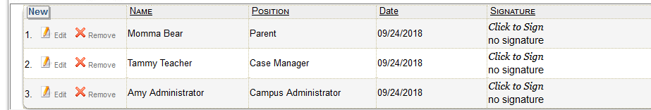
Click on “Click to Sign” for each member present and this screen will appear. You will have to type in each of their names again and select the design of the signature. Click Save for each member.
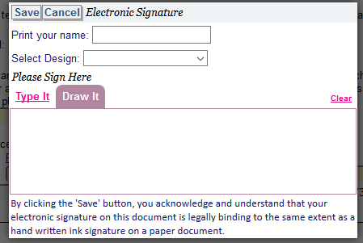
IF YOU CONTACTED PARENT BY PHONE, THEIR SIGNATURE NEEDS TO READ: “See Phone Contact” (you will type this phrase where it says “print your name” under the parent signature.
This is what it will look like with signatures:
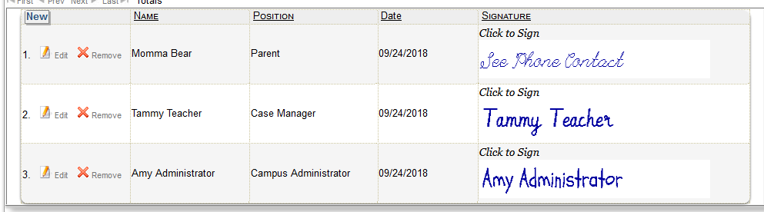
Scroll back to the top of the screen and click “SAVE”. You have completed the IEP Amendment.
Steps for Processing an IEP Amendment to Send to ESC
Log into eSped
Click ARD forms, select student, and click appropriate statement on the FERPA screen
First, from the dropdown screen select “Beginning of ARD” (around screen #9)
Second, select reason for meeting from the dropdown: “IEP Amendment”
Third, select the date of the meeting. (NEVER CHANGE CURRENT ANNUAL REVIEW DATE)
Click “Save”
Click “Reports”
From dropdown, select “Print Multiple Reports”
You will see a list of items on the left side of the screen; (they will be listed alphabetically)
- Double click IEP Amendment and it will move to the right side of the screen
- Double click what you are changing in this IEP amendment: (such as Schedule of Services, goals & objectives, Modifications/Accommodations, etc)
- Double click Parent Contact Log last
- You should have at least 3 items listed on the right side of the screen at this time. Click “Create”
Refresh until you see the status as “Done”.
From the dropdown, click “Archive Prepared Reports”
Type of Archive: – select from dropdown “IEP Amendment”
Folder: – select from the dropdown 18-19 IEP Amendment
Find your report and click “Archive”
------------------------------------------------------------------------------------------------------------------------------------------

Next, you need to create the Computer Data Entry Sheet for SpEd Services
From the dropdown, select “Print Individual Reports”
Scroll down to “Computer Data Entry for SpEd Services”
Click “Create”, “refresh”, then view and print. Then close this screen.
From the dropdown, click “Archive Prepared Report”
Type of Archive: From dropdown, select “Computer Data Entry”
Folder: From dropdown, select 18-19 IEP Amendment
Find your report and click “Archive”

**Attach the Computer Data Entry Sheet in front of the IEP Amendment and turn into Judy Highfield at ESC.**

