Entering Accommodations/Modifications into eSTAR
Log into eSTAR and select a Texas students for training purposes.
Scroll down to “Accommodations” screen:
If student needs accommodations, click Yes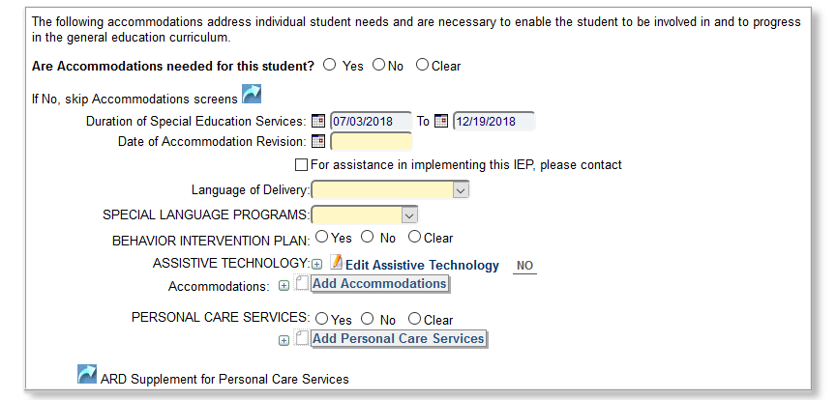
Enter: Duration of services; Language of delivery; Behavior Intervention Plan: Assistive Technology; Personal Care Services
Click “SAVE” before moving to the next screen.
Scroll down to “Accommodations List” screen:
Click on the Bundle dropdown and select Four Core Courses; If you need to add accommodation to other electives, you will need to add them through Custom Subjects.
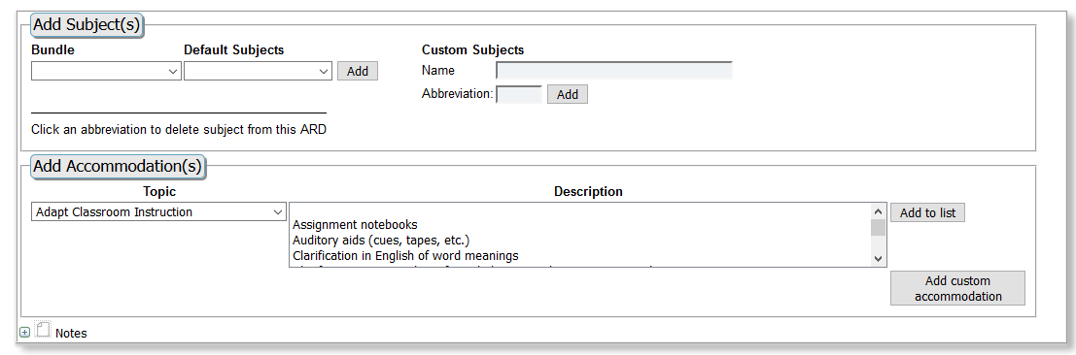
Click on the Topic dropdown and you will see all the areas where you can add accommodations.
Click on the first one “Adapt Classroom Instruction” and a descript of all of those accommodations will appear on the right. When you see an accommodation you want to add, click on it and click Add to List. You can also add custom accommodations of your choice.
Follow this procedure for all of the areas under the Topic dropdown until you have added all appropriate accommodations.
After you have selected accommodations in all needed areas, your screen will look like this.
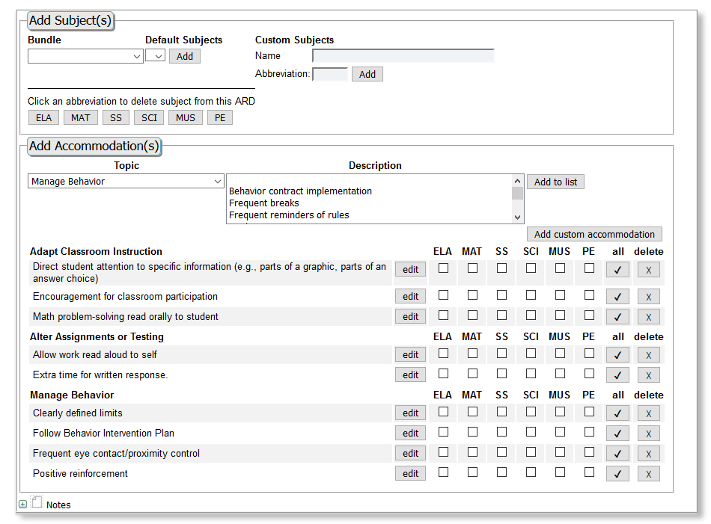

At this time, you click each course where this accommodation is needed. If the accommodation is needed in all courses, you may click “All” and the accommodation will be added to all courses.

Click “SAVE” at the top of the screen.

