Common Problems with eSped/ARD Paperwork
- IEP Amendments
- When creating an IEP amendment, it must be archived and sent to ESC for processing. Once the parent has been contacted, amendment should follow.

- Invitation to ARD
- Make sure you check the box on page 3 (Include Record of Contact Attempts) on ALL invitations.
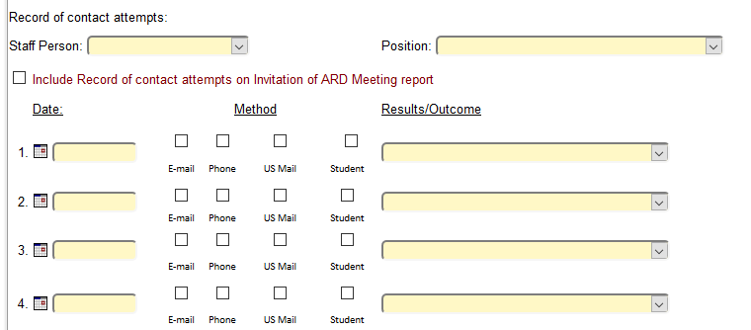
- Make sure you archive the Notice of ARD when it is created.
- Send ALL pages of the invitation with ARD and make sure it has a signature.
- If parent is not present at ARD meeting or participates by phone, there must be something provided to document such as phone contact or parent signing that they will not be in attendance.
- List the parent’s name, NOT mother/father

- Archiving
- If you archive a document in the incorrect folder, do not recreate. In archive manager, click “edit” and this screen will appear:
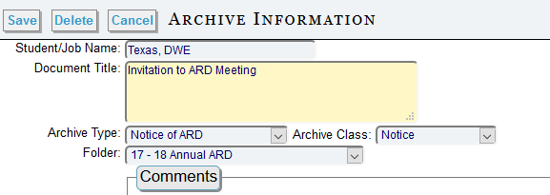
- Move the document to the correct folder and click “save”

- IEP Progress/Updates
- At the annual ARD, the teacher must bring a copy of the completed updated IEPs so they can be processed with the ARD.

- Folders
- DO NOT select the 504 Progress Log folder
- USE: 18-19 IEP Progress Folder for goal progress
Please have your teachers call Judy Highfield @ 87193 if they have any questions.

