DEER PARK INDEPENDENT SCHOOL DISTRICT
Assistive Technology Documentation in ESPED

AT Documentation (in eFIE) in ESPED

When documenting AT evaluations (AT report templates) and/or AT considerations (considerations worksheet) in the
eFIE. In the eFIE screens, choose the “Assistive Technology” screen.

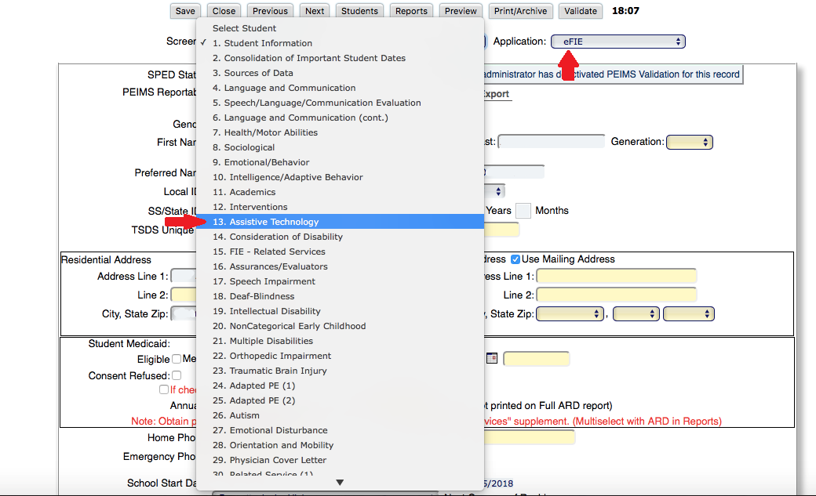

Click here to open the text box where you will paste your AT evaluation report (from WATI, SETT, etc.) or to paste
considerations/determinations from worksheet completed by assessment team.
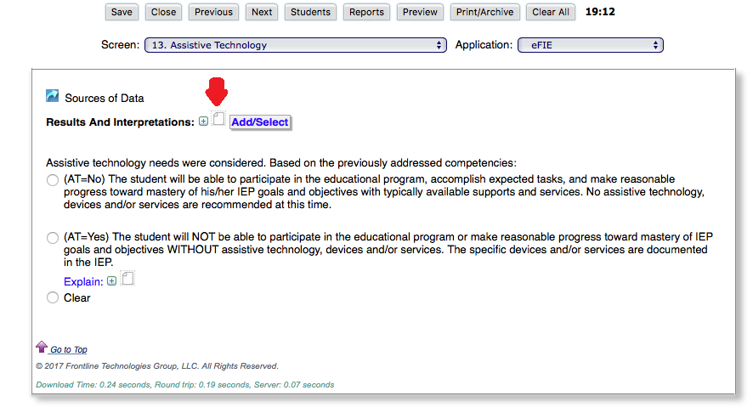

This box will open. You can use the snipping tool to “add image” or you can simply copy and paste information from an
AT evaluation or your AT team considerations and determinations information. Examples are below.

When an evaluation tool, like the WATI guide is used, your data “may” look like the example below with the completed
AT report pasted in (only partially shown below due to length).

If no formal AT evaluation has been completed for a re-evaluation, the Considerations and Determinations information
can be pasted. Your data may be similar to the example below.

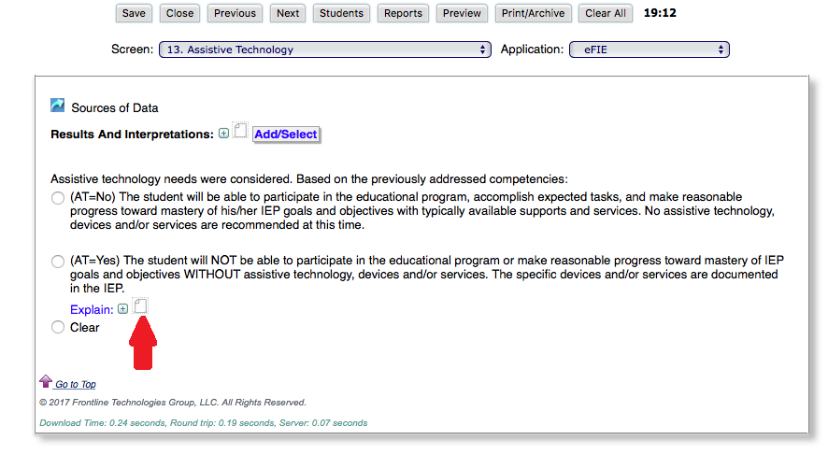

AT Documentation (in ARD forms section) in ESPED

When documenting in the ARD forms section of ESPED, please follow the instructions below Open Communications/Physical/AT Needs of the Student.
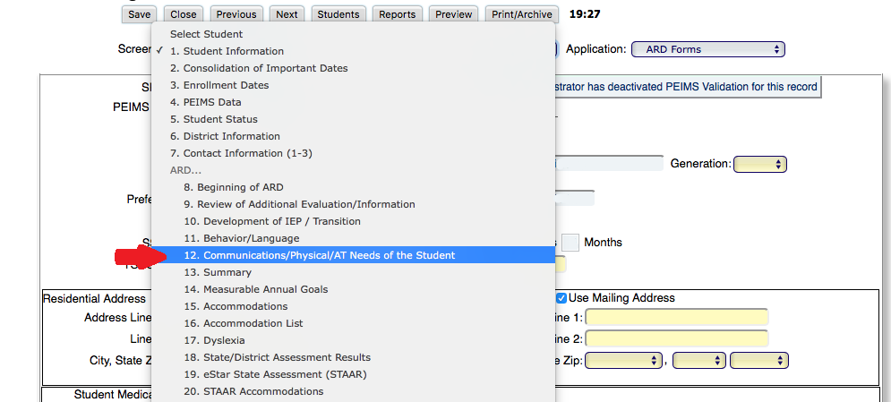
Click here and change the date for initial placement only. All currently served students dates will be prepopulated by ESPED on the 1st day of each school year.
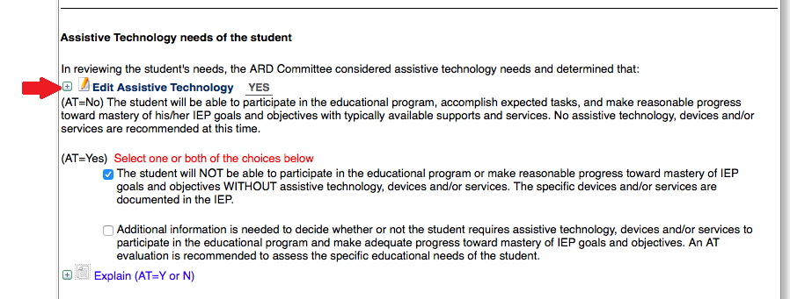
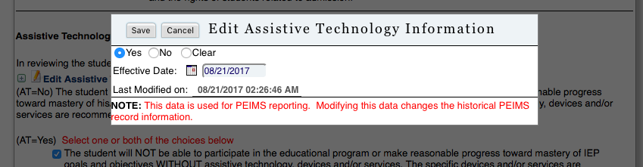

For students not requiring any AT devices please simply choose NO in this box. This will alert PEIMS that this student DOES NOT require assistive technology devices to participate in the educational program, accomplish expected tasks, and make reasonable progress toward mastery of his/her IEP goals and objectives with typically available supports and services.

For students that the team has determined “NEED” AT devices and will NOT be able to participate in the educational program or make reasonable progress toward mastery of IEP goals and objectives WITHOUT assistive technology devices, please check the correct box (as shown) and open the text box to add your data from the Considerations worksheet (pg. 1 of this document).
