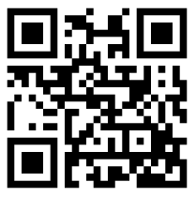

DPISD Special Education Resources: <http://deerparksped.weebly.com/>

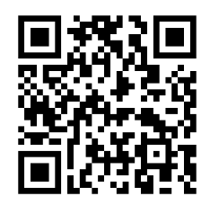

TEA Accommodation Resources: <http://tea.texas.gov/accommodations/>

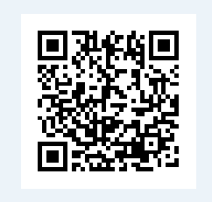

Disability Fact Sheets : <http://www.parentcenterhub.org/repository/specific-disabilities/>

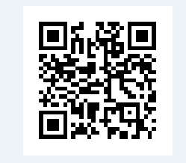

Special Education articles and resources: <http://www.education.com/results/?q=special+education>

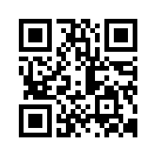

iPads for All Abilities: <http://dpsped.weebly.com/>

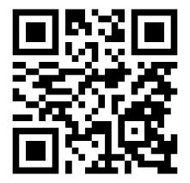

Sped Tex- Special Education Center: <http://www.spedtex.org/>