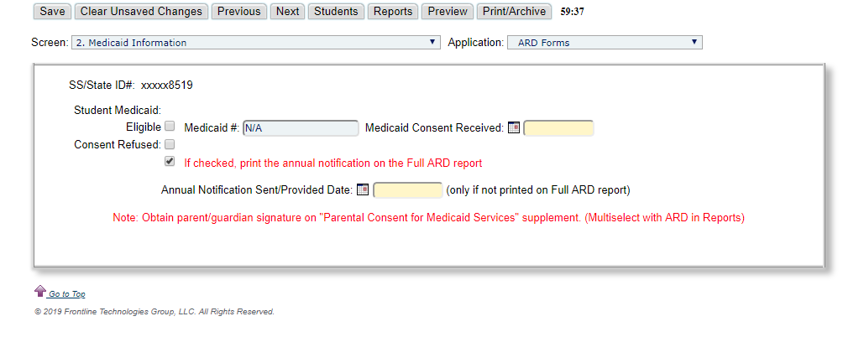

**This box must always be checked for Annual ARD printing (leave checked)**