Skyward Assignments and Attachments

Attachments can be added to your assignments in Skyward
You can do this as you ADD an assignment

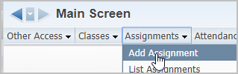

If you want to add an Attachment to an EXISTING assignment….you can do this one of
two ways:
---First Way…… ---Second Way……
Click on the Assignment Header.
Next…you MUST click the EDIT button. **Even though you are seeing the Attach button here….!!!
Now that your assignment is in “edit mode”, click the ATTACH button.
You can click (not hover) on the ASSIGNMENTS – LIST ASSIGNMENTS option.
Then from your list of assignments, highlight the appropriate
assignment line and click the EDIT button

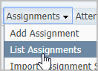
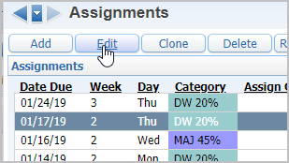
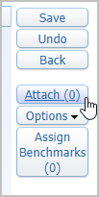
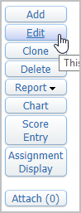
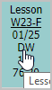
NO….not yet !

1 – Select the CHOOSE FILE button. Browse to the location of your file
2 – Click the UPLOAD button
3 – Click the SAVE button
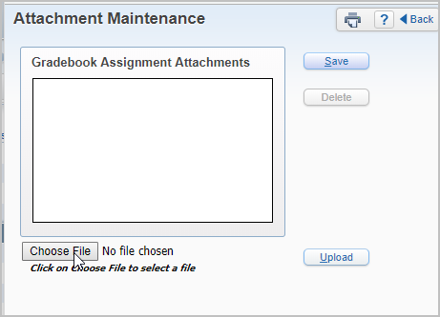
2nd
3rd
1st

You can add multiple attachments.
You can add any type of file.
The number in the parentheses will indicate the number of attachments for that assignment.
Edit the Assignment to access the “ATTACH” button.
You can ADD additional documents to the assignment at any time.
You can VIEW the attached documents.
You can DELETE any of the attached documents.

