Steps in Completing a Revision ARD for SSI
eStar Screen: Revision ARD (1)
- Enter Revision ARD Date of Meeting
- Enter Reason for Meeting
- Enter “Yes” or “No” if an interpreter is being used
- Enter the date of the ARD that this meeting is modifying
DEVELOPMENT OF THE INDIVIDUALIZED EDUCAITON PROGRAM (IEP)
- Are present levels of performance different from those detailed in previous ARD:
- In most cases, you will select “No” Discussion determined no changes in present levels of performance.
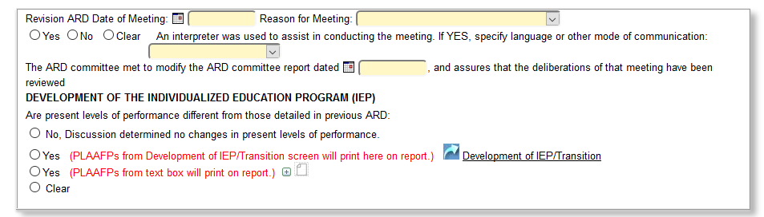
eStar Screen: Revision ARD (2):
The questions below will need to be addressed IF you are changing or adding something in those areas.
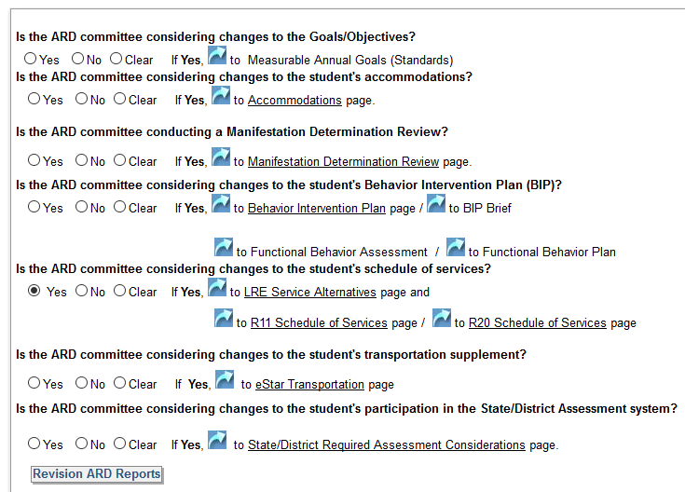
To add accelerated instruction, you will need to click “Yes” on changes to the student’s schedule of services and click the It will direct you to the LRE Service Alternatives (1) where you would mark “Accelerated program of instruction” is being considered. Complete the rest of the LRE Screens.

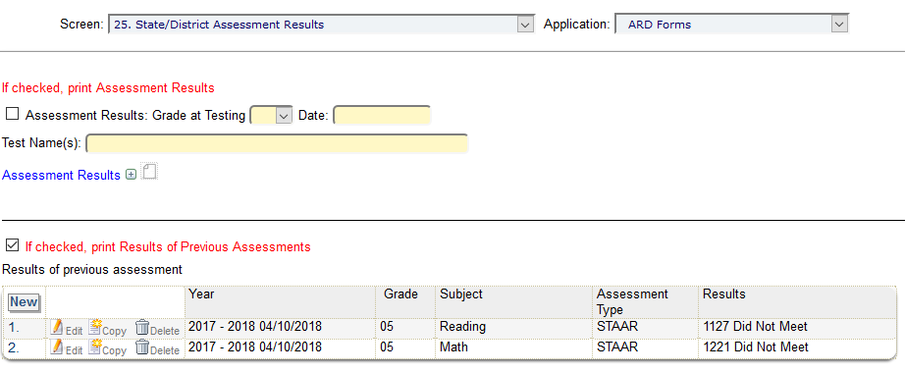
Click “NEW : to add assessment results
Below is the screen where you add accelerated instruction:
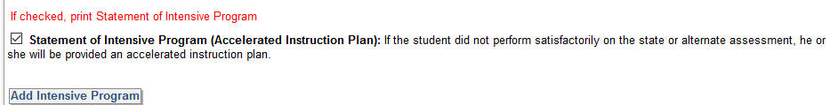
**This is where you add accelerated instruction, for now and after second administration in the event the student does not meet passing standard.

(SAMPLE)
The current accelerated instruction includes __________________. In the event that ______ does not meet passing standard on the second administration, the accelerated instruction will include _____________.

