Transportation Form
eStar Directions
All transportation forms have already been completed for the 2018-2019 school year. The only time you would complete a form for this school year would be if a new service was beginning.
Log into eStar and go to the following screens:
eStar Transportation Supplement (1):
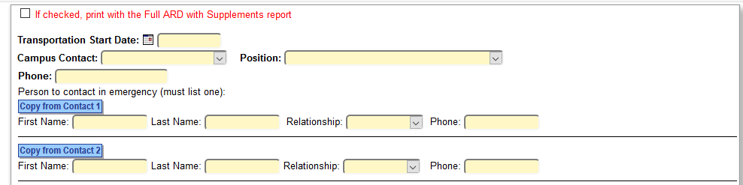
- Enter transportation start date: this will be the first day of school for the 2019-2020 school year or the date the new service was starting.
- Complete contact information: Campus contact, Position, Phone
- Person to contact in emergency: this should be pre-populated in eStar
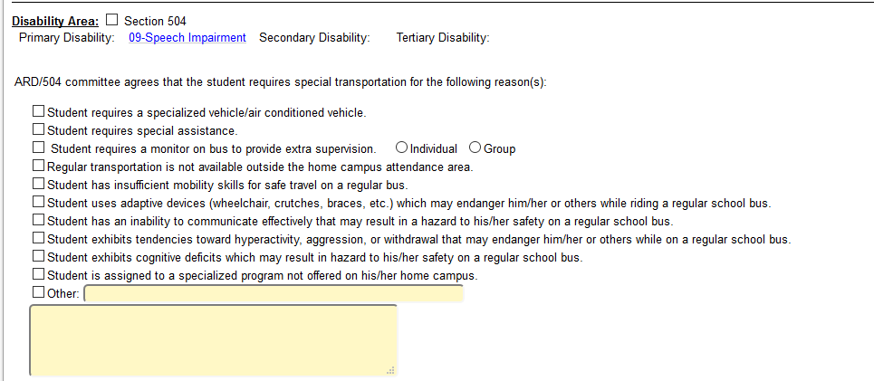
- Disability Area: this should be pre-populated, but if not, add disability area
- ARD/504 committee: check all reasons why the student requires special transportation

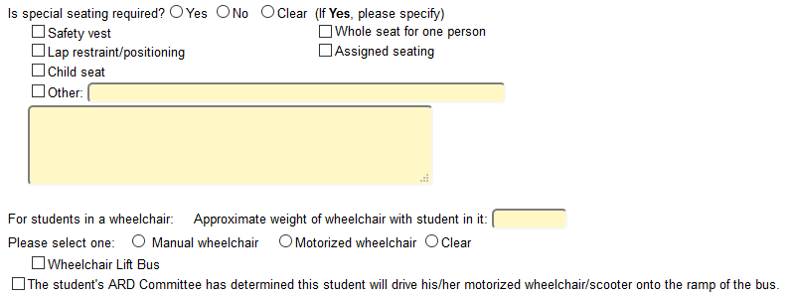
- Special seating required: if you check Yes, make sure you specify type of special seating
- For students in a wheelchair: if a student requires a wheelchair, make sure you check whether it is manual or motorized, check that a wheelchair lift bus is needed, and whether the student with a motorized wheelchair will drive his/her wheelchair onto the ramp of the bus
Click “SAVE” at the top of the page and go to the next screen.
eStar Transportation Supplement (2):
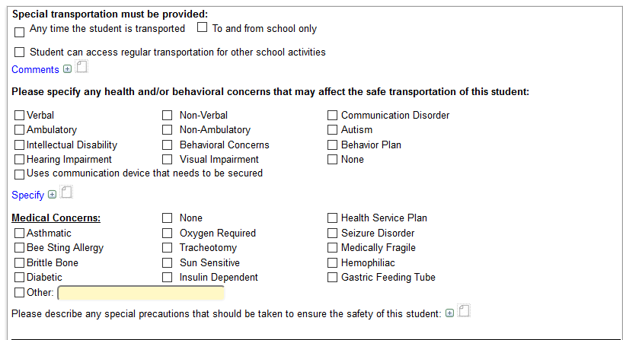

- Special transportation must be provided: check appropriate box
Any time the student is transported
To and from school only
Student can access regular transportation for other school activities

is where you can make comments relevant to when child would receive special transportation or other information you feel needs to be documented.
- Health and/or Behavioral concerns: please check all that apply to the student or check “None”
this is where you could explain details about both health and/or behavioral concerns
- Medical Concerns: check all that apply to the student or “None”

If there are special precautions that should be taken to ensure the safety of the student, please click on the and describe.

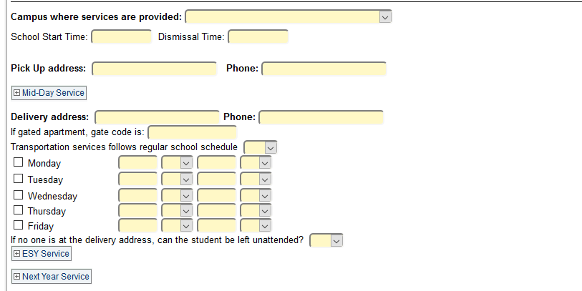
- Campus where services are provided: select from the dropdown;
Make sure you enter the start and dismissal time for the campus.
- Pick Up Address/Phone: enter the address where the student will be picked up and a current phone number
- Delivery Address/Phone: enter the address where the student will be delivered and a current phone number
- Transportation Services follow regular school schedule: should be Yes unless there are special circumstances where the student has an altered school day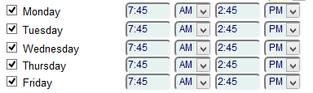
Make sure you put the start and end time for your level: elementary, junior high, high school
- If no one is at the delivery address, can the student be left unattended? You must select yes or no depending on the parent’s request.

Do not enter anything for these two sections at this time. 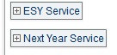
eStar Transportation Supplement (3):
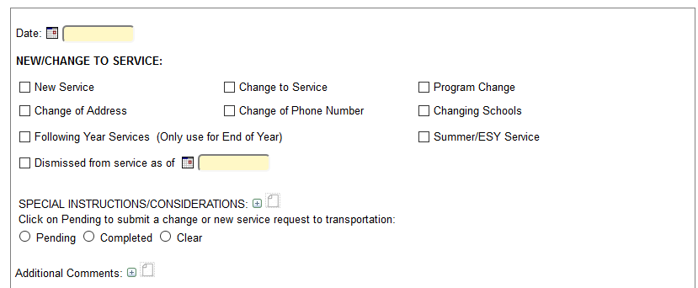
Date: This will be the day services will start. For the 2018-2019 school year, all current students receiving special transportation already have a transportation form completed. If you are adding transportation, then you would put the date for the new service to start.
- New/Change to Service: Check the reason for the new/change to service from the options provided.
- Special Instructions/Considerations: This is the section where you type in the people authorized to receive the student from the bus. Click on the “paper icon” to list contacts and phone numbers
- Click on Pending to submit a change or new service request. Otherwise, click completed.

